ROHM Switching Regulator Solutions

Evaluation Board:

Step-down Switching Regulator

With Built-in Power MOSFET

BD9G101G (5V | 0.5A Output)

No.0000000015

●Introduction

This application note will provide the steps necessary to operate and evaluate ROHM’s step-down switching regulator using the BD9G101G evaluation boards. Board layout recommendations, operation procedures, application data and build of materials are provided.

●Description

This evaluation board has been developed for ROHM’s step-down switching regulator customers evaluating BD9G101G. While accepting a wide power supply of 6-42V, a step down output of 1V-29V can be produced. The IC has an internal 800mohm Nch MOSFET (1A max) and a fixed operating frequency range of 1.5MHz. A Soft Start circuit prevents in-rush current during startup along with UVLO (low voltage error prevention circuit), OCP (over-current protection) and TSD (thermal shutdown detection) protection circuits. An EN pin allows for simple ON/OFF control of the IC to reduce standby current consumption.

●Applications

Industrial distributed power applications

Automotive and battery powered equipment

●Evaluation Board Operating Limits and Absolute Maximum Ratings

|  |  |  |  |  |  |  |  |
| --- | --- | --- | --- | --- | --- | --- | --- |
| **Parameter** | | **Symbol** | **Limit** | | | **Unit** | **Conditions** |
| **MIN** | **TYP** | **MAX** |
| **Supply Voltage** | | | | | | | |
|  | BD9G1010G | VCC | 6 | - | 42 | V |  |
| **Output Voltage / Current** | | | | | | | |
|  | BD9G101G | VOUT | - | 5 | - | V | *Set by R1 and R2 |
|  | BD9G101G | IOUT | - | 0.5 | - | A |  |
|  | | | | | | | |

●Evaluation Board

Below is the evaluation board with the BD9G101G. Component selection and board layout guidelines are provided in the BD9G101G datasheet.

**VOUT**

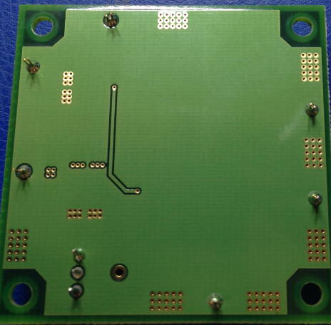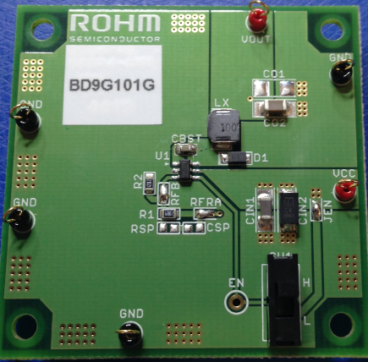

**Vout**

**GND**

**GND**

**VCC**

BD9673EFJ Eval Board

**ENABLE**

**H: Active (IC🡪OFF)**

**L: Inactive**

**(IC🡪ON)**

**EN**

BD9G101G Eval Board (Back)

BD9G101G Eval Board (Front)

●Evaluation Board Schematic

Below is the evaluation board schematic for BD9G101G.

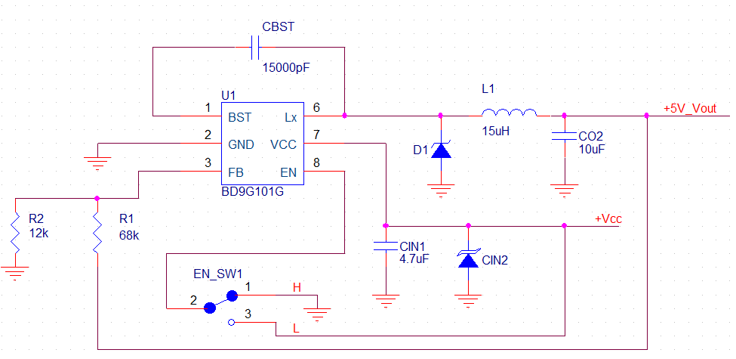

10uH

●Evaluation Board I/O

Below is the reference application circuit that shows the inputs (Vcc and EN) and the output (Vout @ 5V/0.5A)

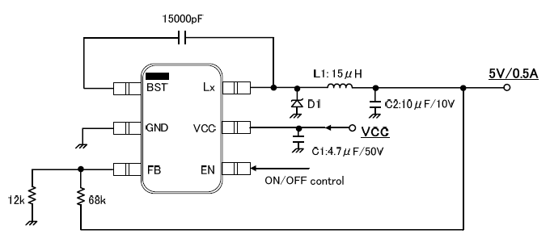

**L1: 10uH**



●Evaluation Board Operation Procedures

Below is the procedure to operate the evaluation board

1. Connect GND to a GND pin on the evaluation board
2. Connect Vcc to the VCC_pin. This will provide Vcc to the Vcc pin of the IC
   * 1. Note: EN pin is pulled HIGH as default. EN needs to be set to LOW for IC operation.
3. Output voltage can be measured from the VOUT_pin on the evaluation board. Output current can be measured with a proper load at VOUT.

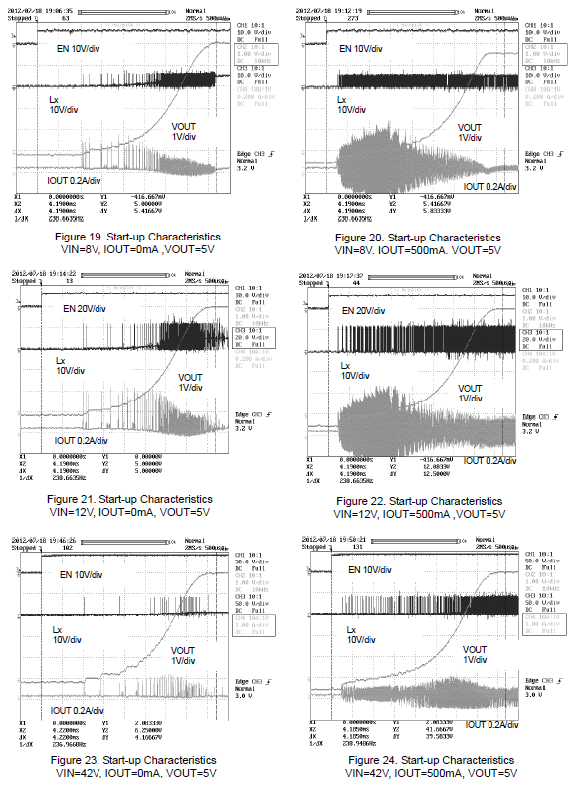●Reference Graphs Application Data for BD9G101G

Below graphs show efficiency, frequency response and load characteristics of the BD9G101G eval board.

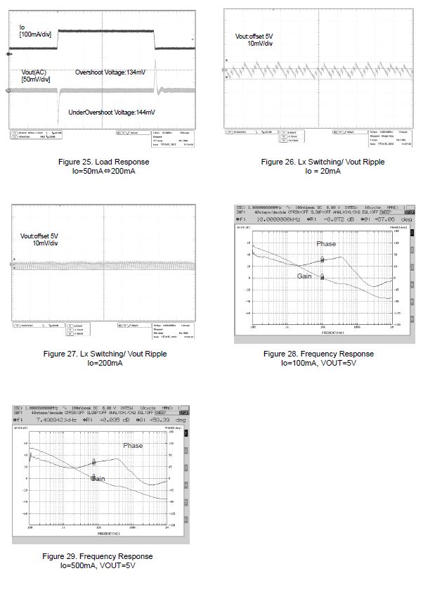

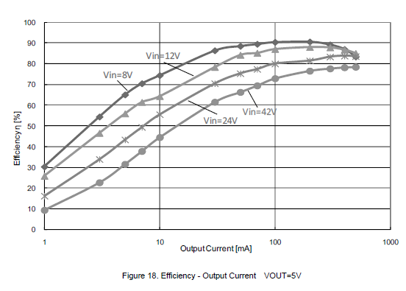

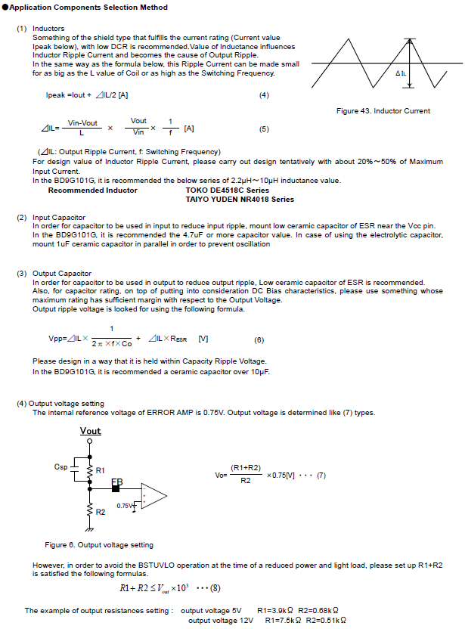

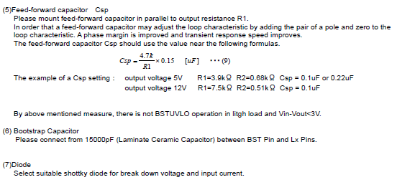

* Note: Feed-forward capacitor Csp is not populated on the BD9G101G evaluation board. The capacitor is recommended for designs requiring improved phase margin and transient response.

●Evaluation Board Layout Guidelines

Below are the guidelines that have been followed and recommended for BD9G101G designs.

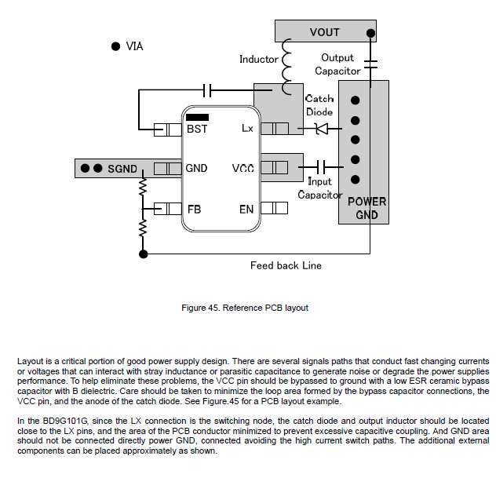

●Evaluation Board BOM

Below is a table with the build of materials. Part numbers and supplier references are provided.

|  |  |  |  |  |  |  |
| --- | --- | --- | --- | --- | --- | --- |
| Item | Qty | Ref | Description | Manufacturer | Part Number | Digikey P/N |
| 1 | 1 | CIN1 | CAP CER 4.7UF 50V Y5V 1206 | Murata | GRM31CF51H475ZA01L | 490-1828-1-ND |
| 2 | 1 | CIN2 | DIODE TVS 30V 400W UNI 5% SMA | Littlefuse | SMAJ30A | SMAJ30ALFTR-ND |
| 3 | 1 | CO2 | CAP CER 10UF 10V 10% X5R 1206 | Murata | GRM31CR61A106KA01L | 490-1820-2-ND |
| 4 | 1 | CBST | CAP CER 0.015UF 50V 10% X7R 0603 | Murata | GRM188R71H153KA01D | 490-1514-1-ND |
| 5 | 1 | D1 | DIODE SCHOTTKY 60V 2A PMDU | ROHM | RB060M-60TR | RB060M-60CT-ND |
| 6 | 1 | SW1 | SWITCH SLIDE SPDT 30V.2A PC MNT | E-Switch | EG1218 | EG1903-ND |
| 7 | 1 | R1 | RES 68.0K OHM 1/8W 1% 0805 SMD | Yageo | RC0805FR-0768KL | 311-68.0KCRCT-ND |
| 8 | 1 | R2 | RES 12.0K OHM 1/8W 1% 0805 SMD | Yageo | RC0805FR-0712KL | 311-12.0KCRCT-ND |
| 9 | 1 | LX | INDUCT 10uH SOD-106 | TOKO | DEM4518C 1235AS-H-100M | - |
| 10 | 1 | U1 | 5V, 0.5A Step-down SW Reg w/ FET | ROHM | BD9G101G | - |

